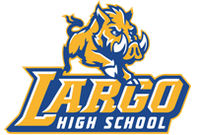
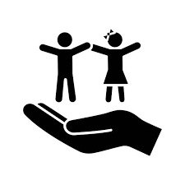
Largo High School
Little Packers Education Academy

Career Cluster: Education & Training
Career Pathways: Teaching and Training; Professional Support Services; and Administration and Administrative Support.
Early Childhood Education Program Courses
9th Grade |  |  |  | 10th Grade
Early Childhood Education 1  *DCF Certifications: CAAN, HSAN, CGDR |  |  |  | Early Childhood Education 2 or Childcare Worker 2 *DE  *DCF Certifications: BOSR, UDAP, PSPR
11th Grade |  |  |  | 12th Grade
Early Childhood Education 3 or Teacher Aide *DE  *DCF Certifications: RNRF, & VPK Early Literacy |  |  |  | Early Childhood Education 4 or Preschool Teacher *DE  *Florida Staff Credential and National CDA
Post-Secondary Programs
Pinellas Technical College |  |  | St. Petersburg College
Child Care Center Operations (45 hrs.)  Early Childhood Education Apprenticeship (2000 hrs.)  School Age Professional Certificate (120 hrs.) |  |  | SPC’s bachelor’s degrees will prepare you to become a Florida Certified teacher for grades K-12. Students who successfully complete the Early Childhood Education program and obtain the Florida Staff Credential are eligible to articulate up to 6 college credits towards the Educational Studies Early Childhood Education A.A. degree at SPC.
High School to Postsecondary Education and Training
1–2 year Certificate | Associate Degree |  |  |  |  | Bachelor’s degree
Florida Staff Credential  Florida Director Credential  National Child Development Associate (CDA)  School Age Professional Certificate | Educational Studies Early Childhood Education A.A.  Middle Grades General Science Education A.A. |  |  |  |  | Early Childhood Education: Pre- Kindergarten/Primary Education  Educational Studies and Community Leadership  Interdisciplinary Education  Elementary Education  English Education  Exceptional Student Education  Exercise Science  Mathematics Education  Physical Education  Secondary Mathematics Education  Science Education  Social Science Education
Resources:  https://www.aafcs.org/  https://NAEYC.org  https://www.skillsusafl.org/  https://gettherefl.com/ |  | Educators Rising  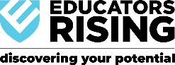  is a Career and Technical Student Organization (CTSO) for students in the Education & Training Pathway. |  |  | SkillsUSA  is a Career and Technical Student Organization (CTSO) for students in the Education & Training Pathway.  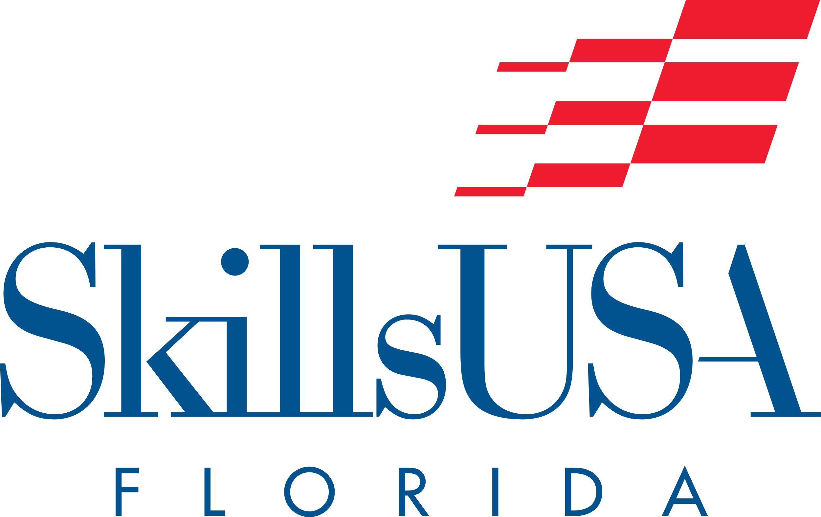
*DE – Dual Enrolled with Pinellas Technical College
**This program requires students to obtain 480 hours of direct work experience with children 5 years old or younger while enrolled in the program to be awarded the Early Childhood Professional Certificate (ECPC).

