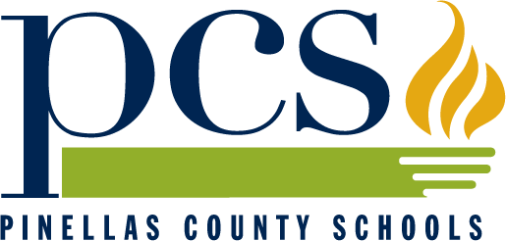

[www.pcsb.org](http://www.pinellas.k12.fl.us)

**ASL, CHINESE, ESOL, FRENCH, GERMAN, GREEK, ITALIAN, SPANISH**

**Teachers of world languages use best practices and state**

**standards to facilitate student success in the global community.**

Dear Friend of World Language Education,

The world languages and ESOL teachers and students of Pinellas County Schools invite you to participate as a judge in the annual International Day. Judges are needed to judge banners and projects, as well as speaking events and skits. We thank you in advance for considering the offering of your time to support this event, which would not be possible without the assistance of many volunteers. We are proud of our teachers and students and welcome the opportunity to include university faculty and students and community members in this celebration of language learning. We encourage you to join us and to consider inviting a friend to judge with you. Below are some important details on this year’s event:

**What**: **Pinellas County International Day**

**Where**: Meadowlawn MiddleSchool

6050 16th St. N.

St. Petersburg, FL 33703

727-570-3097

**When**: **Saturday, March 1, 2014**

**Times**: 8:00-8:55 a.m. Judges’ Meeting – Media Center

9:00-9:30 a.m. Opening Ceremony – Cafeteria

9:45-12:00 p.m. Judging

11:30-12:30 p.m. Pizza Lunch/Café: You are invited to be our guest for lunch!

*Note: Hands-on cultural workshops and other activities will also take place throughout day. Guest judges will receive a schedule of events and are invited to visit those activities as they are able.*

**Who to Contact**: If you are able to serve as a judge, please contact:

**Leticia Calhoun**, World Languages Secretary, Pinellas County Schools

e-mail: [calhounl@pcsb.org](mailto:calhounl@pcsb.org)

phone: 727-588-6072

If you have any questions, please call:

**Jan Kucerik,** World Languages Specialist

e-mail: kucerikj@pcsb.org

Phone: 727-588-6072

Fax: 727-588-5185

We will need your name, phone number, e-mail address and the language(s) you speak.

**Pinellas County Schools Volunteers Registration Process**

If you ARE NOT currently employed by Pinellas County Schools and have not previously registered as a volunteer, we ask that you take the time to register using the “Volunteer Registrations” form found on the district website at [www.pcsb.org/volunteer](http://www.pcsb.org/volunteer) and e-mail or mail the completed form to Michelle Roberge ([robergem@pcsb.org](mailto:robergem@pcsb.org)) or volunteer@pcsb.org, District Volunteer Coordinator, (301 4th Street S W, Largo, FL 33770). If this is not possible, we will partner you with a Pinellas County teacher during the judging process, per Pinellas County Schools district policy.

If you have already registered previously, it is only necessary for you to “Activate Your Volunteer Status” at [www.pcsb.org/volunteer](http://www.pcsb.org/volunteer)

***Danke, Gracias, Grazie, Merci, Arigato, Xie xie, Efcharisto, Gratia***