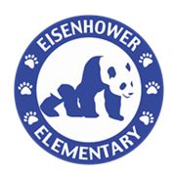**Supply List**

**Second Grade Class**

**USB Headphones for computer - small and inexpensive are fine**

**(Please place in Ziploc bag with child’s name)**

* **packages of #2 pencils – sharpened if possible**
* **3 prong folders with pockets (one of each- yellow, green, red, and blue)**
* **1 box of Crayola crayons and/or Crayola colored pencil**
* **wide ruled composition books (journals) - yellow, green, red**
* 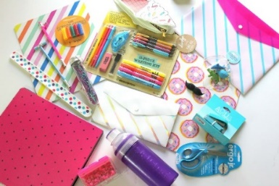**erasers (pink or pencil caps)**
* **tissues**
* **scissors**
* **unopened, store bought healthy snacks**

**(such as pretzels, crackers, Goldfish, animal crackers, vanilla wafers, etc…)**

* **Clorox or Lysol Wipes**
* 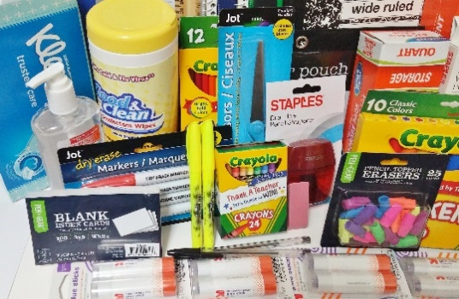**Hand Sanitizer**
* **Ziploc bags (gallon and quart)**
* **glue sticks**
* **pencil box/pouch**
* **Expo dry erase markers**
* **1 yellow highlighter**
* **white copy paper**

**Individual teachers may have additional requests.**

**Please check with your child’s teacher at the beginning of the year.**

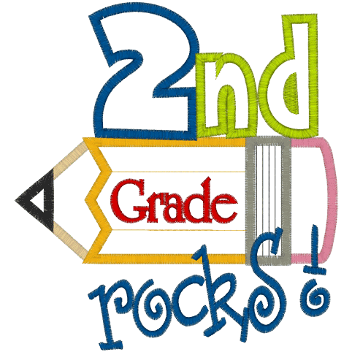

**Thank You,**

Second Grade Team