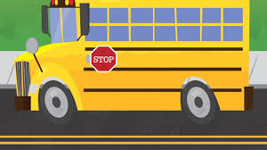

As we are prepare to leave one school year behind, here are some supply items that will help next year get off to a great start! Please remember that school supplies are ***optional,***and all items necessary will be provided.

4th Grade Supply List (Optional)

* 2 packs of wide ruled paper
* Pencils, non- mechanical
* Ear buds/ headphones (Walmart, Dollar Tree)
* Dry Erase Markers

* Wish list: tissues, hand sanitizer, gallon (boys) and sandwich (girls) size zip-lock bags.

Thank you for partnering with us and having your child prepared for learning!