**Gulf Beaches**

**Elementary Magnet School**

**2024-2025**

**4th Grade Suggested School Supply List**

* **4 composition notebooks (red, yellow, blue, green)**
* **5 plastic two pocket folders with prongs (red, yellow, blue, green, & design of your choice)**
* **#2 pencils (Preferred: Mirado or Ticonderoga)**
* **Colored pencils and/or markers**
* **Pencil case/box**
* **2 jumbo Elmer’s glue sticks** 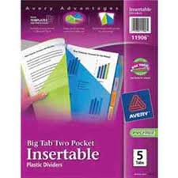
* **Four-pack of Expo Markers (Fine Tip preferred)**
* **Headphones or earbuds (student use- please label with name)**
  + **USB port preferred as not all headphone ports work**
* **1 pair of student scissors**
* **1 box of cap erasers**
* **2 boxes of tissues**
* **2 rolls of paper towels**

**4th grade Wish List**

* 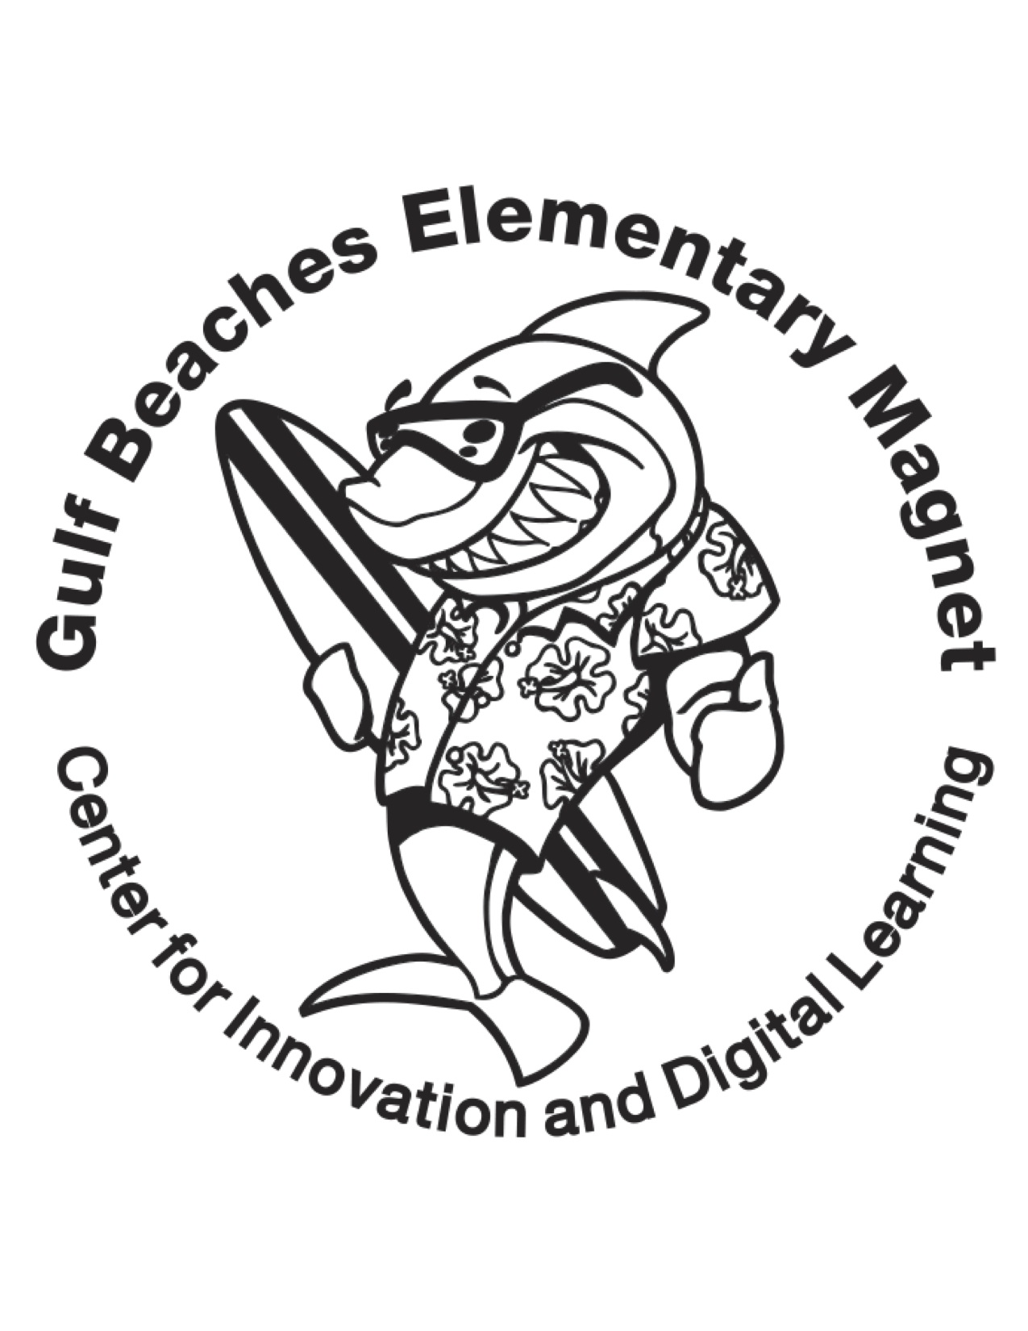**Astrobrights paper**
* **Clorox/Lysol wipes**
* **Hand soap/sanitizer**
* **Expo markers- chisel tip**
* **Crayola Markers**
* **Gel/Flair Pens**