2024-2025 Gulf Beaches Elementary Magnet School

2nd Grade Suggested Supply List

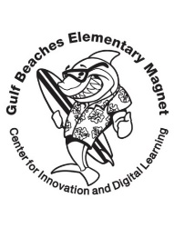

* Student Scissors
* Pencils (Ticonderoga please)
* Pencil Top Erasers
* Kleenex
* Hand Sanitizer
* Glue Sticks
* 2 Wide Ruled Composition Notebooks (labeled with your child’s name)
* Plastic 3 prong-pocket folders (1 red, 1 blue, 1 green)- Label with your child’s name
* Black Expo Markers
* 1-Inch White Binder (labeled with your child’s name)
* 1 Box of Crayons
* Disinfecting Wipes
* Ziploc Bags (boys- gallon, girls-quart)
* 1 pair of headphones with a USB port (labeled with your child’s name)