2024-2025 Gulf Beaches Elementary Magnet School

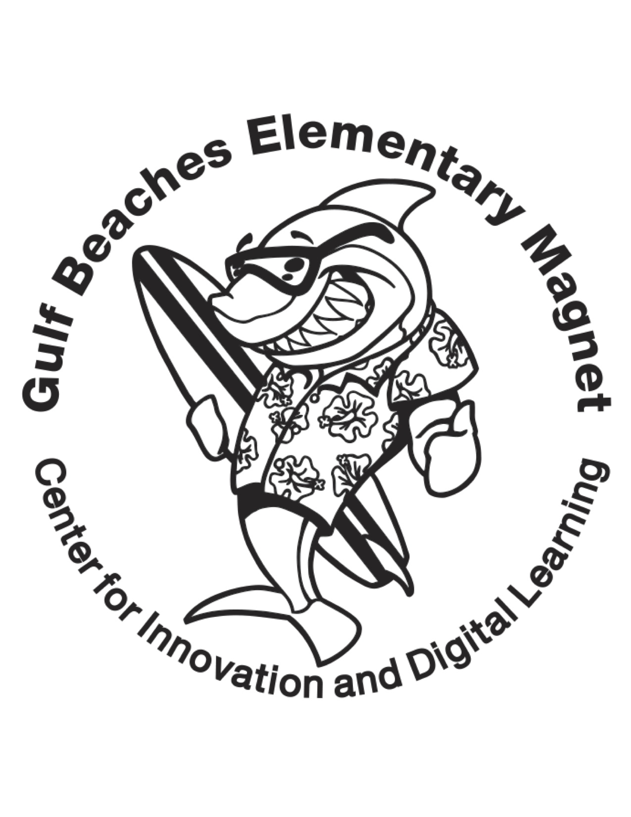1st Grade Suggested School Supply List

One Backpack – No WHEELS!

Clear Plastic Pencil Storage Box

2 – Packages of Pencils (Ticonderoga) – NO Sharpeners!

1 – Package of big pink Erasers (no pencil top erasers)

2 – Boxes of 16 count Crayola Crayons

1 - Box of Crayola Washable Markers

1 – Package of bullet tip black Dry Erase Markers (for white board)

3– Glue Sticks (.74 ounce or larger)

2 – Composition Notebooks Wide Ruled

4 – Plastic folders with pockets (2 blue, 1 red and 1 green **w/prongs**)

1 – Set of headphones for and computer use PLEASE LABEL

**Wish List:**

Hand soap

Paper towels

Baggies of all sizes

Tissues

Clorox Wipes

**Please bring supplies to Open House.**