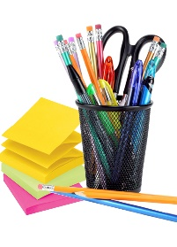**Eisenhower Elementary**

**5th Grade Supply List**

**2024-2025**

|  |  |  |
| --- | --- | --- |
|  | **Item** | **Quantity** |
|  | Composition notebooks | 3 |
|  | Notebook paper (wide ruled) | 1 |
|  | Copy paper (white paper) | 1 |
|  | 1 inch binder | 2 |
|  | 3 prong folder (plastic) | 2 |
|  | Sheet protectors | 1 |
|  | Package of pencils (yellow no. 2) | 2 |
|  | Dry Erase Markers | 1 pkg. |
|  | Highlighters | 1 pkg. |
|  | Headphones or Earbuds | 1 |
|  | Tissue box | 2 |
|  | Clorox wipes | 1 |