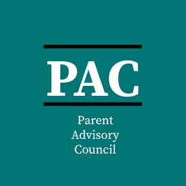
The Parent Advisory Council (PAC) wants you!

Why should you join PAC?
- Network and connect with other families across the district
- Share resources that are available to support your student (and your family)
- Dynamic Guest Speakers related to various topics, such as parent training
- Provide feedback on how to best support your student and others in your school community

Meetings:
PAC will meet virtually or in-person with the district’s Title I staff twice a year. One meeting in the Fall 2023 and the other meeting will be held in the Spring 2024.
Join us:
Please join us in representing your school and community as a member of PAC for the 23-24 school year by completing these simple steps:
- Complete the PAC interest form (see QR Code below!) OR use the link below: https://forms.office.com/r/r5daaMTENE\

- Invite a Friend!

We cannot wait to see you there!
