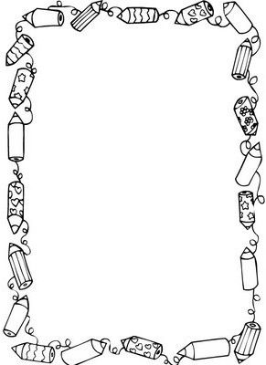

**First Grade Classroom Supplies and Wish List**

Parents,

Listed below are the supplies that your student will need to be prepared for learning. This list is designed in mind for the activities we will be implementing throughout the school year.

- Backpack: small, without wheels

- 1-inch binder

- 4 Primary Composition Journals

- 4 Folders: 4 pronged, 2 pockets (red, green, blue, yellow)

- Pencil box

- Pencils: 3 dozen (Dixon **Ticonderoga\*** only please)

- Large Pink Erasers: 2 three-packs

- Crayons: 2 packs, 24 count, **Crayola\***

- 1 pack of colored pencils

- Markers: 10-pack, classic colors

- Liquid school glue: 2 bottles

- Scissors: 1 pair, child size

- Black Expo Markers: Fine tip (1 pack)

- Sticky Notes

- Index cards

**Wish List (Donations)**

- Disinfecting wipes: 1 pack (Clorox type, no baby wipes)

- Hand Sanitizer

- Facial tissues: 2 boxes, family size

- Paper Towels, 2 rolls

- Zip-lock bags: 1 box quart size, 1 box gallon size

- Expo Markers: (Regular tip, black and color packs)

Thank you so much,

First Grade Team