1st Grade School Supply List
Please do not label any of the supplies with your child’s name, as we use the supplies as a classroom community throughout the year.
2 packs of Ticonderoga Brand #2 pencils  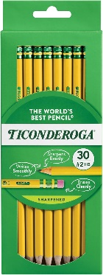 | 2 boxes of Crayola 24 crayons  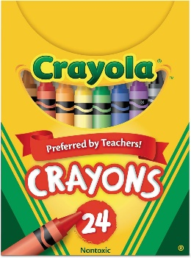 | 2 packages (3-count +) ELMER’S glue sticks (regular size)  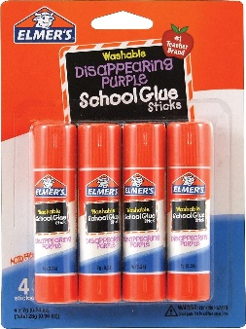
1 composition book WIDE RULED PAPER (preferably Blue)  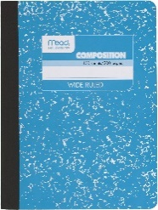 | 2 packages of EXPO BLACK dry erase markers – FINE TIP  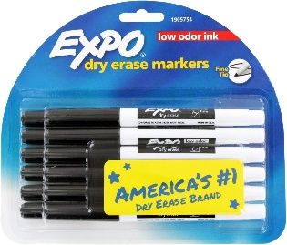 | 1 three ring binder (1 inch) with pockets with clear front plastic pocket  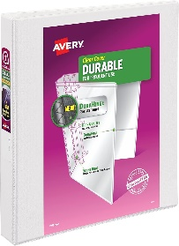
Headphones  (to keep at school)  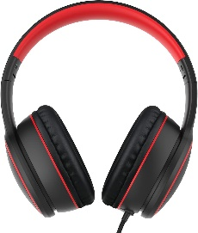 | Clorox wipes  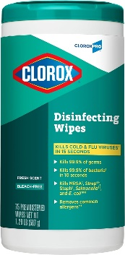

Wish List Items
*If you are able to donate 2-3 of the below items, we would greatly appreciate it.
- Large bottles of anti-bacterial hand sanitizer
- Boxes of Kleenex tissue
- Boxes of quart sized zip lock bags (boys)
- Boxes of gallon sized zip lock bags (girls)
- Paper towels
- 8 ½ x 11 laminating sheets
- Band-aids
- 1 ream of white computer paper
- Post-It Notes (Large and Small)

