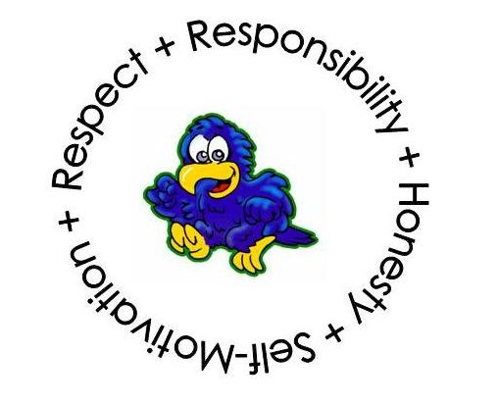

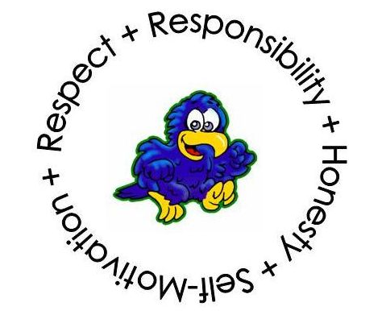

**Seminole Elementary School**

**National School of Character**

10950 74th Avenue North

Seminole, Florida 33772

Diane Cato (727) 547-7668 *phone* Reva Faust

Principal (727) 545-6585 *fax* Assistant Principal

February 6, 2015

Dear Business Owner,

Seminole Elementary School is having a Centennial Celebration on Saturday, May 2nd. The school was opened on its current site with two teachers in the fall of 1915 and is one of the oldest buildings in our city. The school is celebrating the 100 year anniversary with the whole community. We have an event planned that day from 11a.m. to 3 p.m. including fun, food and entertainment. We will have a special ceremony at 1 p.m. with honored guests including city, county and school officials including former principals of Seminole Elementary.

We are asking businesses to help sponsor Seminole Elementary School’s Centennial Celebration. Attached is our sponsorship package. Money raised for the event will also be used to help purchase technology for the students.

We would love for all of you to attend the event as we celebrate our 100 years of excellence.

We also invite you to be a part of the school’s permanent history by donating a brick to the school. The bricks are $30 each.

We look forward to your help in sponsoring our school for this historical event.

Thank you,

Diane Cato, Principal  
Seminole Elementary School