1st Grade Supply List

These are the supplies your child will use in 1st grade! All supplies are optional. If you can provide them, we would appreciate it.

* 1 standard size plastic pencil box

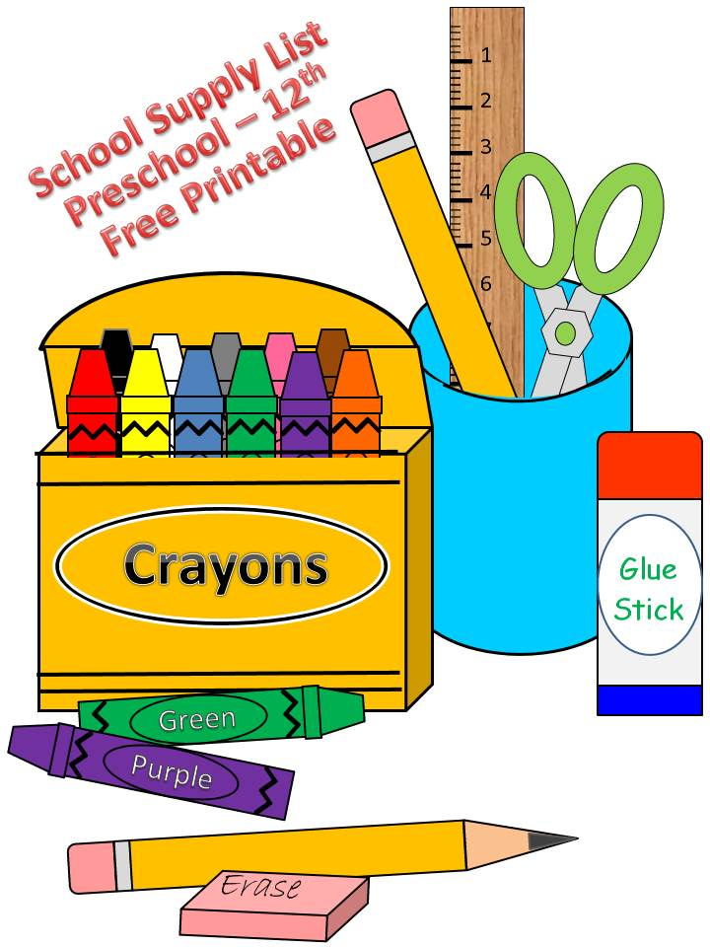

* 4 jumbo glue sticks
* 1 pack of #2 pencils (sharpened)
* 2 boxes of 24 count crayons
* Student/child scissors
* 1 box of black dry erase markers
* Clorox Wipes
* Zip –Lock Baggies
* Tissues
* 1 pack of lined 3 x 5 index cards
* Headphones (these will be for your child only)

Wish List

* Crayola twistable crayons
* Ziploc baggies (all sizes)
* Paper plates (all sizes)
* Colored Copy paper
* Markers
* Tissue paper
* White paper lunch bags
* Treasure box items
* Tubs of foam letters, numbers, shapes, etc.
* Playdough
* Stickers
* Plastic-ware (spoons, forks, knives)
* Post-It Notes
* Dry erase markers

\*\*\* Items on our wish list are things that we purchase or that we use on a regular basis. We may also request additional supplies at various times during the school year. Donations are always welcome and greatly appreciated! \*\*\*

MC900105220[1]