PreK 3:
- Cot or crib sheet and blanket
- Change of clothes- uniform top & bottom, underwear and socks (In labeled Ziplock bag)
- Pull ups/wipes (unscented) Please send pull ups with side tabs, if possible, it makes the changing process much easier (if your child requires them)
- Package of Glue sticks
- 2 packs Crayons (Large Crayola)
- 1 normal school size Backpack (not on wheels) must be large enough to hold folder and nap items.
- Lunch box with ice pack if not eating school lunch
- 1 pair of blunt tip scissors
- 1 box of Crayola washable markers
- Water bottle with covered straw and labeled

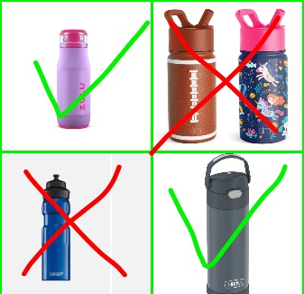
· Please label all of your child's personal items with their first and last name.
· Please make sure lunch items are easy for your child to open and that food that may be a choking hazard is cut into small pieces. For example (Grapes, hot dogs, and carrots) please do not send items that need to be heated up because we will not have access to a microwave if food needs to stay warm, please send it in a thermos or hot food container.

VPK:
- Backpack (full size, no wheels)
- Refillable Water bottle (labeled with first and last name)
- Extra set of clothes (labeled in Ziploc bag) - (Underwear, shirt, pants, socks)
- Blanket and crib sheet for rest time (full day only)
- 1 Can of Lysol Spray
- 1 Canister of Lysol Wipes
- 1 Box of Tissues
- 1 pack of 24 crayons
- 1 1-inch white binder
- 1 Plastic folder
- 2 4-pack Elmer’s Glue Sticks
- 1 pack fine tip black dry erase markers
- 1 plastic pencil box
PreK ASD:
- Backpack (full size)
- ½” white binder
- 1 can of Lysol spray
- 1 Lysol wipes
- 1 box of tissues
- 1 package paper towels
- Extra set of clothes (labeled in Ziploc bag) (shirt, pants, socks)
- Fitted crib sheet and Blanket for rest time
- 1 pack dry erase markers
- 1 pack washable markers

